1) Which feature most clearly separates Dai Mai from a Gall Bladder Sinew route?
A) Dai Mai crosses the waist transversely. +++++
B) Dai Mai begins at a finger.
C) Gall Bladder Sinew enters paired zangfu.
D) Gall Bladder Sinew begins at a Luo point.
Feedback: The transverse belt-like waist course is the defining geometry that separates Dai Mai from a longitudinal lateral Sinew route. Why are the other options incorrect? Dai Mai begins at a finger. — Dai Mai is not identified by a finger origin. Gall Bladder Sinew enters paired zangfu. — Sinew Channels do not enter paired zangfu. Gall Bladder Sinew begins at a Luo point. — The Gall Bladder Sinew route is not defined by a Luo-point origin.
2) Which feature best separates Yang Qiao Mai from a Gall Bladder Sinew route?
A) A lateral heel-to-eye ascent +++++
B) A broad series of muscular binding regions
C) Origin at GB-37
D) Deep paired-organ convergence
Feedback: Yang Qiao Mai is recognized by its characteristic ascent from the lateral heel toward the eye. Why are the other options incorrect? A broad series of muscular binding regions — Broad muscular bindings favor a Sinew route. Origin at GB-37 — GB-37 is the origin of the Gall Bladder Luo route. Deep paired-organ convergence — Deep paired-organ convergence favors a Divergent route.
3) A posterior route includes a point-bearing external pathway and selected internal branches. Which Bladder system fits better than the broad posterior Sinew chain?
A) Bladder Primary Channel +++++
B) Bladder Sinew Channel
C) Bladder Luo-Connecting Channel
D) Bladder Divergent Channel
Feedback: A point-bearing posterior external route with internal branches identifies the Bladder Primary Channel. Why are the other options incorrect? Bladder Sinew Channel — The Sinew route is broad, superficial and marked by bindings rather than a point sequence. Bladder Luo-Connecting Channel — The Luo route begins at BL-58 and connects with Kidney. Bladder Divergent Channel — The Divergent route separates and enters deeply before convergence.
4) A posterior route separates near the knee, enters deeply in relation to Kidney and Bladder, and ascends toward the nape. Which route is it?
A) Bladder Primary Channel
B) Bladder Sinew Channel
C) Bladder Luo-Connecting Channel
D) Bladder Divergent Channel +++++
Feedback: Posterior-knee separation, deep paired-organ entry and ascent toward the nape identify the Bladder Divergent Channel. Why are the other options incorrect? Bladder Primary Channel — The Primary route is the ordinary point-bearing reference pathway. Bladder Sinew Channel — The Sinew route remains superficial and binds across the posterior body. Bladder Luo-Connecting Channel — The Luo route begins at BL-58 rather than separating deeply near the knee.
5) Which feature separates the Great Luo of the Spleen from Dai Mai?
A) It spreads across the lateral chest from SP-21. +++++
B) It circles the waist transversely.
C) It rises from the lateral heel to the eye.
D) It follows a Foot Yang point sequence.
Feedback: The Great Luo of the Spleen spreads from SP-21 across the lateral chest rather than girdling the waist. Why are the other options incorrect? It circles the waist transversely. — A transverse waist course identifies Dai Mai. It rises from the lateral heel to the eye. — Lateral heel to eye identifies Yang Qiao Mai. It follows a Foot Yang point sequence. — The Great Luo is not a Foot Yang Primary point sequence.
6) Which evidence prevents every short branch from being labeled a Luo-Connecting Channel?
A) A Luo route should have a named Luo-point origin and characteristic connection or destination. +++++
B) A Luo route must always circle the waist.
C) A Luo route always enters both paired zangfu.
D) A Luo route must bind at every joint.
Feedback: Luo identification requires the characteristic Luo-point origin and connecting destination, not merely the presence of a branch. Why are the other options incorrect? A Luo route must always circle the waist. — Circling the waist identifies Dai Mai. A Luo route always enters both paired zangfu. — Entering paired zangfu is a Divergent feature. A Luo route must bind at every joint. — Multiple joint bindings are Sinew features.
7) Which clue best distinguishes a Primary route from a Sinew route when both occupy a similar limb surface?
A) Ordered point-bearing line and internal branches versus broad muscular bindings +++++
B) Red line versus blue line
C) Long title versus short title
D) Presence versus absence of an organ name
Feedback: The Primary system uses an ordered point-bearing reference course, while the Sinew system shows broad superficial binding regions. Why are the other options incorrect? Red line versus blue line — Color is not standardized across diagrams. Long title versus short title — Title length has no anatomical meaning. Presence versus absence of an organ name — Both systems may share the same organ-family name.
8) A lateral route links Yang regions of the shoulder and head but does not girdle the waist. Which vessel is the better fit?
A) Yang Wei Mai +++++
B) Dai Mai
C) Great Luo of the Spleen
D) Liver Luo-Connecting Channel
Feedback: Yang Wei Mai links lateral Yang regions, including shoulder and head, without the transverse belt course of Dai Mai. Why are the other options incorrect? Dai Mai — Dai Mai is transverse around the waist. Great Luo of the Spleen — The Great Luo spreads across the lateral chest from SP-21. Liver Luo-Connecting Channel — The Liver Luo begins at LIV-5 and continues toward the genital region.
9) What is the channel shown in the image?
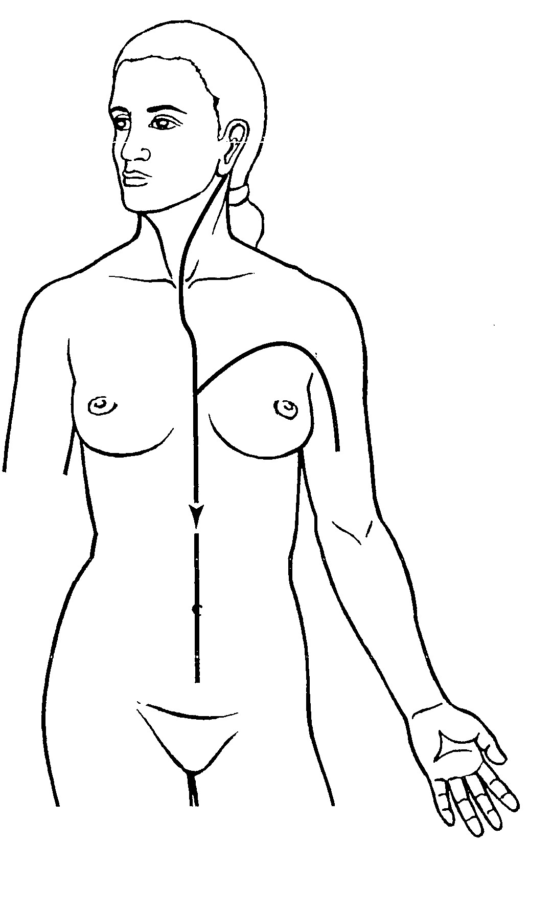
A) Pericardium Primary Channel
B) Pericardium Divergent Channel +++++
C) Pericardium Luo-Connecting Channel
D) Pericardium Sinew Channel
Feedback: The Pericardium Divergent Channel separates below the axilla, enters the chest and relates internally to the three jiao, then ascends through the throat and emerges behind the ear to join the paired Sanjiao pathway. Why are the other options incorrect? Pericardium Primary Channel — The Primary Channel is the point-bearing chest-to-hand route. Pericardium Luo-Connecting Channel — The Luo-Connecting Channel begins at PC-6 and follows a more limited connecting course. Pericardium Sinew Channel — The Sinew Channel is superficial and musculotendinous.
10) What is the channel shown in the image?
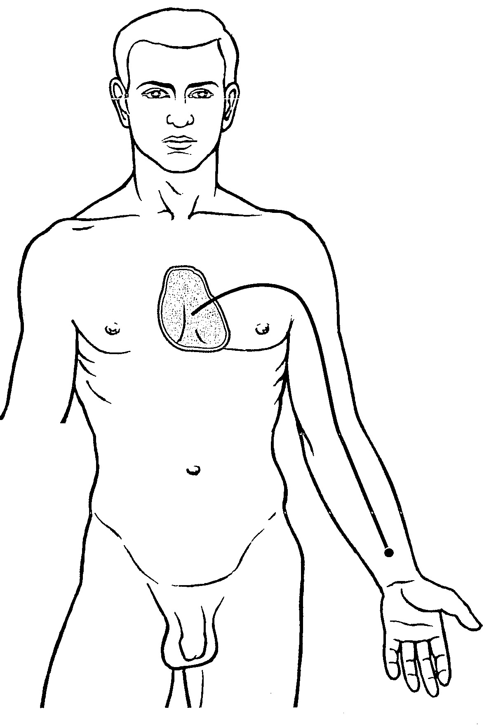
A) Pericardium Primary Channel
B) Pericardium Divergent Channel
C) Pericardium Luo-Connecting Channel +++++
D) Pericardium Sinew Channel
Feedback: The Pericardium Luo-Connecting Channel begins at PC-6 on the forearm, connects with the paired Sanjiao Channel and ascends with the Pericardium pathway into the chest to reach the Pericardium and connect with the Heart. Why are the other options incorrect? Pericardium Primary Channel — The Primary Channel is the complete point-bearing chest-to-hand pathway. Pericardium Divergent Channel — The Divergent Channel is recognized by deeper paired-channel convergence. Pericardium Sinew Channel — The Sinew Channel forms a superficial musculotendinous route.

